河西区2018-2019学年度第二学期三年级学习质量自查
一、听力部分
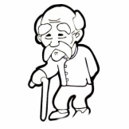
I. Look, listen and number. 看图，听录音，用数字标出朗读的顺序。


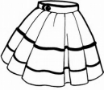
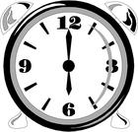

II. Listen and choose. 选出你所听到的单词，将其字母编号填在题前的括号里。
( ) 1. A. classroom B. school C. desk
( ) 2. A. Nice B. Glad C. Good
( ) 3. A. night B. evening C. morning
( ) 4. A. Who B. How C. What's
( ) 5. A. aunt B. uncle C. brother
( ) 6. A. peaches B. vegetables C. bananas
( ) 7. A. small B. short C. big
( ) 8. A. yellow B. yacht C. fruit
( ) 9. A. Ten B. Nine C. Eleven
( ) 10. A. oh B. old C. name
III. Listen and choose. 听录音，根据所给情景选择最佳答案，将其字母编号填在题前的括号里。
( ) 1. Sam指着远处的T恤衫说：
( ) 2. 再一次见到高伟你很高兴，你这样向他表达：
( ) 3. 你这样向你的新朋友介绍自己：
( ) 4. 今天是妈妈的生日，你应对她说:
( ) 5. 李红想知道那位男士是谁，她这样问你：
( ) 6. 如果那位男士是你爷爷，你这样告诉她：
( ) 7. 你想让高伟给你看看他的家庭照片，你这样对他说：
( ) 8. 你想询问Lisa是否喜欢吃水果，你这样问她：
( ) 9. 你想邀请同学吃糖果，你这样说：
( ) 10. 你想用英文解释一下nest的含义，你这样说：
IV. Listen to the questions and choose the best answers. 从A、B和C 选项中找出你所听到的英语句子的最佳答语。
( ) 1. A. I’m in Class Three. B. I’m in Grade Three. C. I’m Number Three.
( ) 2. A. Yes, I do. B. Yes, I like hot dogs. C. Yes, I am.
( ) 3. A. He’s my brother. B. She’s tall. C. She’s my sister.
( ) 4. A. It’s an elephant. B. That’s my grandfather. C. I’m in the box.
( ) 5. A. Five exercise books. B. Here you are. C. In our school.
二、读写部分
（一）根据图意找出正确的单词或词组，将其字母编号写在括号内。
A. a sharpener B. fruit C. a box D. two chairs E. chicken
F. a doughnut G. ice cream H. a parrot I. six bears J. a doll

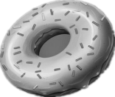
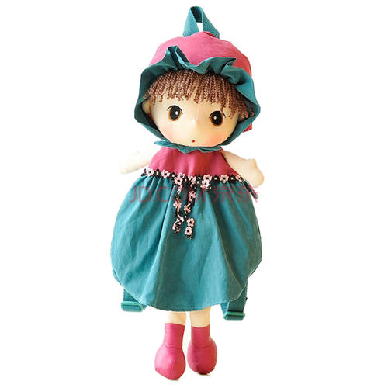

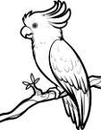

( ) ( ) ( ) ( ) ( )
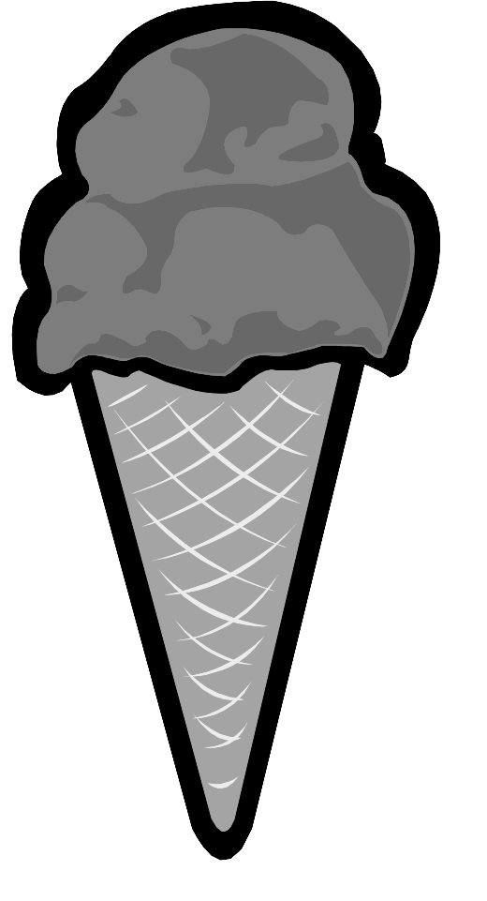
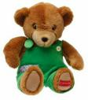

( ) ( ) ( ) ( ) ( )
（二）圈出每组中不同类的词。
1. bread cake candy desk | 2. mother school uncle sister
3. vest shirt ship uniform | 4. rooster father daughter sister
5. tiger lion quail twelve | 6. plane skirt yacht boat
（三）从A 、B和C选项中找出能填入空白处的最佳选项。
( ) 1. -What’s in my bag? - ________ English book.
A. An B. A C. Two
( ) 2. -What’s that? -________ a book.
A. She’s B. It’s C. He’s
( ) 3. -How old is Gao Wei? -He’s ________.
A. fine B. nine C. Number Nine
( ) 4. -Is that your shirt? -No, it ________.
A. is B. isn’t C. don’t
( ) 5. -________ time is it? -It’s one o’clock.
A. What B. Who C. How
( ) 6. What’s ________ name?
A. your B. I C. he
( ) 7. I’m in ________ Three, ________ Two.
A. Class; Grade B. Grade; Class C. / ; /
( ) 8. She’s my ________.
A. uncle B. aunt C. grandfather
( ) 9. This is a ________. It can fly.
A. rabbit B. fish C. bird
( ) 10. -An ice cream, please. - ________
A. You’re welcome. B. Oh, no. C. All right. Here you are.
（四）从方框内选择合适的应答语句，将字母编号写在括号内。
( ) 1. Can I see it?
- A music room and a gym.
- OK, let’s go!
- Sure. Here you are.
- Yes, I do.
E. Not very well.
F. It’s eleven o’clock.
G. No, thanks.
H. Pleased to meet you.
I. I’m ten.
J. No, it’s a chick.

( ) 2. What’s in your school?
( ) 3. Let’s go home.
( ) 4. Have a doughnut, Sam.
( ) 5. How are you?
( ) 6. Do you like candy?
( ) 7. How old are you?
( ) 8. Is it a quail?
( ) 9. What time is it?
( ) 10. This is Miss Li.
（五）按照正确的格式抄写下面的句子，注意大小写及标点符号。
1. I'm in class five grade six

2. good morning miss liu

3. is this your shirt no it isn’t

（六）根据所给图将句子补充完整。
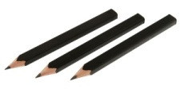
1. I can see three new .

5+7=12
- and is .

- That’s .

4. -Who’s that boy? -He’s my . I’m his sister.

5. Here are some for you.

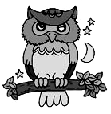

6. This is .


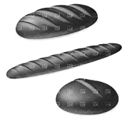

7. I like and .

（七）阅读下面的短文，根据其内容选择正确答案。
My favourite animal is a dog. My uncle has a dog. Her name is Shirley. She is my friend. She is 5-year-old. Her fur (皮毛) is grey and white. She’s tall and fat. She looks like a sheep (绵羊). She has a beautiful dress. She’s very quiet. She doesn’t like to move (移动). That’s her house. Look! She is sitting (坐) in it. She looks like a toy dog. Shirley is very cute. I love Shirley.
( ) 1. Shirley is _________ dog.
A. my B. my uncle’s C. my friend’s
( ) 2. Shirley and the writer (作者) are _________.
A. classmates B. friends C. boys
( ) 3. How old is Shirley?
A. Five. B. Four. C. Three.
( ) 4. Shirley doesn’t have a _________.
A. dress B. home C. toy dog
( ) 5. Which is Shirley?
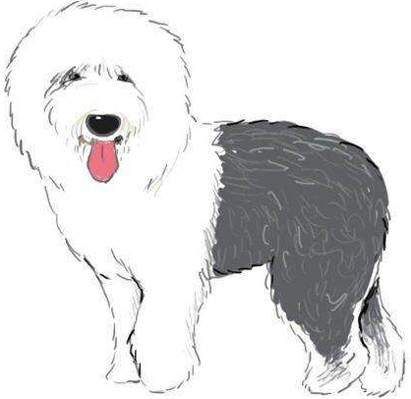
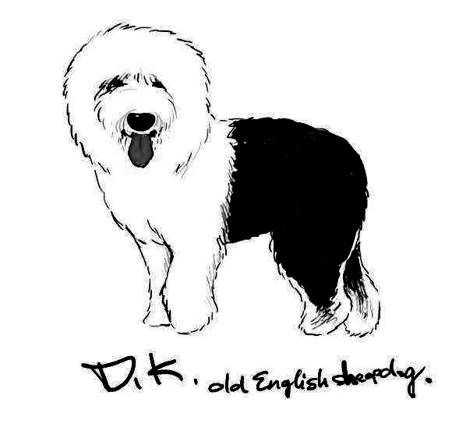
A. B. C.
