五上英语学科第三单元基础题 姓名 班级
III. Listen to the questions and choose the right answers. 根据问句选择正确的答语。
（ ）1. A. He’s my brother. B. She’s my friend. C. He’s a student.
（ ）2. A. She’s from China. B. She’s a teacher. C. She wants to be a teacher.
（ ）3. A. They work in a factory. B. They live in Beijing. C. They come from Beijing.
（ ）4. A. I want to go to America. B. I am a fireman. C. I want to be a postman.
（ ）5. A. No, she isn’t. B. No, he isn’t. C. No, he doesn’t.
（ ）6. A. Yes, she is. B. Yes, she does. C. Yes, he does.
（ ）7. A. He comes from Australia. B. She lives in Australia.
C. She comes from Australia.
1. Who’s that boy?
2. What’s your aunt’s job?
3. Where do your parents work?
4. What do you want to be in the future?
5. Is your uncle a student?
6. Does your father like singing? 7. Where does the girl come from?
三. 用括号里所给词的适当形式填空。
1. We love our mother and father and they love_________ (we).
2. He often __________ (help) people in his work.
3. I _________ (be) eleven now.
4. Look at ____________ (today) newspaper.
5. We should learn from ___________ (he).
6. My mother and aunt are both __________ (actress).
7. I want ____________ (be) a dancer.
8. Let __________ (I) introduce my family to you.
9. My uncle is an (act).
10. What is __________(he) job?
四. 根据所给情景填空，一空一词。
1. 如果你想知道Linda的妈妈是干什么工作的，你可以这样问Linda：
____________ does your mother do?
如果她的母亲是一名记者，她这样回答： ____________ a reporter.
2. Kate想知道报纸上的这位男士是谁，她这样问你：
____________ the man in the newspaper?
如果是你的爸爸，你这样告诉他：____________ my ____________.
3. 如果你想知道Cathy是干什么工作的，你可以这样问王彤：What’s ____________ job?
如果她是个演员，王彤这样回答你： ____________ an actress.
4. 你想把自己的父母介绍给大家，你说：Let me introduce my ____________ to you.
5. 你想知道Miss Li是哪里人，你可以这样问她：____________ are you from?
如果她是天津人，她这样回答：I’m ____________ _______________.
6. 你想知道 Lucy的哥哥是不是个工人，你这样问Lucy: ________ your brother a worker?
如果是，她这样回答你： Yes, _________ __________.
7. 你向朋友介绍你的全家福，你这样说： Here is a picture _________ my _________.
五. 从A、B和C三个选项中找出能填入空白处的最佳选项。

( ) 1. My mother is a nurse. __________ your aunt?
A. How B. How about C. What
( ) 2. Let___________ introduce my new friend. A. my B. me C. I
( ) 3. -Who’s the man? -_____________
A. He is my uncle. B. She is my sister. C. He is a farmer.
( ) 4. What _____ you want ______ in the future?
A. do, to be B. do, be C. does, to be
( ) 5. - What’s her job? -_____________
A. She is my sister. B. She is a waitress. C. Her father is a teacher.
( ) 6. -______ your mum a reporter? A. Are B. Does C. Is
( ) 7. Tom is very______. He wants a _________ from England.
A. friend, friendly B. friends, friend C. friendly, friend
( ) 8. -What’s ______ job? - ______ a doctor.
A. his; His B. his; He’s C. he’s; His
( ) 9. Tom and Mike are ______.
A. twins brother B. twin brothers C. twins brothers
( ) 10. My sister is __________actress. A. an B. a C. /
( ) 11. -Is she a ________? - Yes, she _______.
A. dancer; does B. dance; is C. dancer; is
( ) 12. He looks great ________ his uniform. A. in B. on C. of
( ) 13. I like ________ very much.
A. sing B. singing C. sings
( ) 14. -_________ she? -She’s my mother’s friend.
A. What’s B. Who’s C. Who
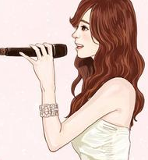
六．用完整句回答问题。
1. Is Lisa a factory worker?
______________________________
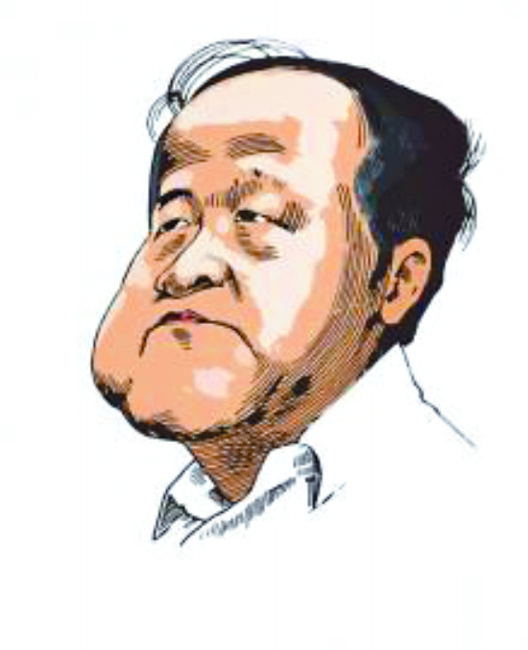
2. Who is he?
Mo Yan
_______________________________
What does he do?
_______________________________
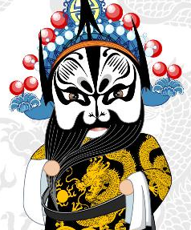
3. What do you want to be in the future?
_____________________________

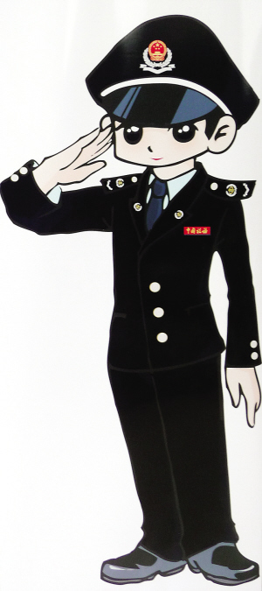
4. What’s your uncle’s job?
_______________________________

