**2020-2021学年度第二学期三年级学习质量自查**

学校

班级

姓名

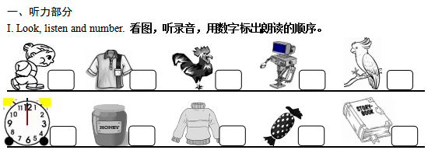**英 语 试 卷**

II. Listen and choose. **选出你所听到的单词，将其字母编号填在题前的括号里。**

|  |  |  |
| --- | --- | --- |
| ( ) 1. A. seven | B. desk | C. nest |
| ( ) 2. A. nine | B. nice | C. fine |
| ( ) 3. A. night | B. evening | C. morning |
| ( ) 4. A. Who | B. How | C. What's |
| ( ) 5. A. brother | B. uncle | C. friend |
| ( ) 6. A. candy | B.eggs | C. cakes |
| ( ) 7. A. small | B. short | C. big |
| ( ) 8. A. yellow | B. yacht | C. fruit |
| ( ) 9. A. sunny | B. son | C. Sunday |
| ( ) 10. A. zebra | B. zip | C. Chinese |

III. Listen and choose. **听录音，根据所给情景选择最佳答案，将其字母编号填在题前的括号里。**

**( ) 1. 你这样向你的新朋友介绍你的父亲：**

**( ) 2. 再一次见到高伟你很高兴，你这样向他表达：**

**( ) 3. “让我们一起去上学吧。”你这样对高伟说：**

**( ) 4. 今天是妈妈的生日，你应该对她说:**

**( ) 5. 高伟想知道你的年龄，他这样对你说：**

**( ) 6. 你10岁了，你这样告诉他：**

**( ) 7. 你想让高伟给你看看他的家庭照片，你这样对他说：**

**( ) 8. 你不喜欢吃面包和热狗，你这样表达：**

**( ) 9. 你邀请同学吃鸡蛋，你这样说：**

**( ) 10. 你想告诉大家那不是猫而是一只猫头鹰，你应该说：**

第1页

IV. Listen to the questions and choose the best answers.  **从**A**、**B**和**C **选项中找出你所听到的英语句子的最佳答语。**

( ) 1. A. I’m fine. B. I’m Number Nine. C. I’m nine.

( ) 2. A. I’m in the classroom. B. I’m in Grade Three. C. I’m in Class Three.

( ) 3. A. He’s my brother. B. She’s tall. C. She’s my sister.

( ) 4. A. It’s eight o’clock. B. It’s a big owl. C. No, I don’t like it.

( ) 5. A. Yes, it is. B. This is your uniform. C. It’s a uniform.

二、读写部分

**（一）根据图意找出正确的单词或词组，将其字母编号写在括号内。**

1. a marker B. fruit C. a yacht D. six bears E. some bread

F. a classroom G. some eggs H. sister I. brother J. a coat

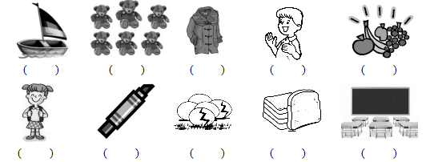

**（二）圈出每组中不同类的词。**

|  |  |
| --- | --- |
| 1. book ruler hand bag | 2. daughter son doughnut sister |
| 3. sweater shirt ship uniform | 4. fruit coffee juice Coke |
| 5. tiger lion quail eight | 6. plane skirt yacht boat |

**（三）从A 、B和C选项中找出能填入空白处的最佳选项。**

( ) 1. He’s my________.

A. father B. mother C. sister

( ) 2. -What’s that? -________ a book.

A. She’s B. It’s C. He’s

( ) 3. What’s __________ name?

A. you B. your C. you’re

( ) 4. -Is that your shirt? -No, it ________.

A. is B. isn’t C. don’t

第2页

( ) 5. -________ time is it? -It’s one o’clock.

学校

班级

姓名

A. What B. Who C. How

( ) 6. I like _______ and ________.

A. bread, apples B. bread, apple C. breads, apples

( ) 7. –What’s in my bag? – ________ English book.

A. An B. A C. Two

( ) 8. That’s a ______________.

A. owl B. kangaroo C. egg

( ) 9. –Excuse me. Is that your watch? –Oh! ____________

A. Here you are. B. Yes, it is. C. All right.

( ) 10. –Thank you. –________

1. You’re welcome. B. OK. C. Oh, no.

**（四）从方框内选择合适的应答语句，将字母编号写在括号内。**

( ) 1. I like milk. What about you?

1. A music room and a gym.
2. Thank you.
3. Me too.
4. Yes, I do.

E. Not very well.

F. He’s my brother.

G. OK, fruit.

H. Sure. Here you are.

I. I’m ten.

J. No, it’s a chick.

( ) 2. What’s in your school?

( ) 3. Happy birthday to you.

( ) 4. Show me your fruit.

( ) 5. How old are you?

( ) 6. Do you like candy?

( ) 7. How are you?

( ) 8. Is it a quail?

( ) 9. Who’s that boy?

( ) 10. Can I see your notebook?

**（五）按照正确的格式抄写下面的句子，注意大小写及标点符号。**

1. I'm in class five grade six

图片1

2. do you like coffee miss liu

图片1

3. what’s in my bag a chinese book

图片1

1. 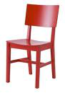**根据所给图将句子补充完整。**

图片2

1. Look at my new .

第3页

图片4图片2图片2图片2

1. and is .



图片2图片2

1. That’s .

图片2

1. This is my . She’s my father’s sister.

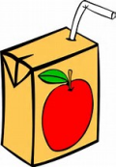

图片2

1. Here’s some juice for you.

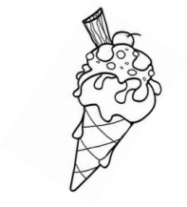

图片2图片2

1. I don’t like .

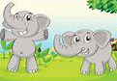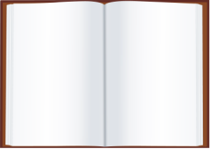

图片2图片2

1. -What’s in the storybook? - .

**（七）阅读下面的短文，根据其内容判断正误， 对的画√，错的画×。**

Dear grandma,

Thank you for the new watch . It’s very nice! Pink is my favourite colour. Tomorrow (明天) will be my 9-year-old birthday. I can wear (穿) my pink T-shirt with the watch. I will go to Beijing Zoo with my mum and dad. There are many animals in the zoo. We can see tigers, monkeys, pandas, zebras and more (另外更多的). I like monkeys very much. My parents loves them, too. I wish we could make friends (交朋友) with animals and protect (保护) them.

How are you these days? Please write (写) to me.

Your love,

Mary

( ) 1. Mary likes pink very much.

( ) 2. The birthday gift (礼物) from grandma is a nice T-shirt.

( ) 3. Mary and her parents will go to the zoo.

( ) 4. Grandma likes monkeys.

( ) 5. Mary is a nice and kind (有爱心的) girl. 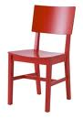

**4+7=11**

第4页

第4页

学校

班级

姓名

第5页

第6页

学校

班级

姓名

第7页

第8页