中文名: 迪斯尼最爱儿歌系列
资源格式: 光盘镜像
版本: ape
发行时间: 2009年
地区: 大陆
对白语言: 英语
文字语言: 英文
简介:
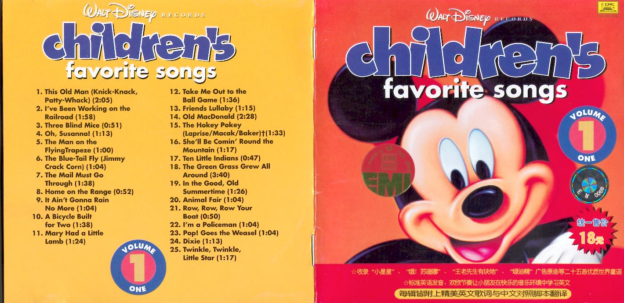
"迪斯尼最爱儿歌系列
格式:APE
容量:906M
作文地带提供简介
“两只老虎”、“ABC歌”、“哦！苏珊娜”、“小小世界”……六十多年来迪斯尼的欢乐王国伴随着无数的大小朋友度过了温馨难忘的童年。此次迪斯尼所企划推出的“最爱儿歌系列1~4辑”一共收录了100首童谣，不论是呀呀学语的小宝宝或是已届学龄的儿童都非常适合。标准清晰的英语发音、欢欣节奏让小朋友在快乐的音乐环境中学习英文。
在快乐的音乐环境中，亲子之间互动学习，充分达到寓教于乐的效果。
曲目：
Walt Disney Records : Children's Favorite Songs, Vol. 1
01.This Old Man (Knick-Knack,Patty-Whack)
02.I've Been Working On The Railroad
03.Three Blind Mice
04.Oh,Susanna!
05.The Man On The FlyingTrapeze
06.The Blue-Tail Fly (Jimmy Crack Corn)
07.The Mail Must Go Through
08.Home On The Range
09.It Ain't Gonna Rain No More
10.A Bicycle Built For Two
11.Mary Had A Little Lamb
12.Take Me Out To The Ball Game
13.Friends Lullaby
14.Old MacDonald
15.The Hokey Pokey(Laprise/Macak/Baker)
16.She'll Be Comin'Round The Mountain
17.Ten Little Indians
18.The Green Grass Grew All Around
19.In The Good,Old Summertime
20.Animal Fair
21.Row,Row,Row Your Boat
22.I'm A Policeman
23.Pop!Goes The Weasel
24.Dixie
25.Twinkle,Twinkle,Little Star
Walt Disney Records : Children's Favorite Songs, Vol. 2
01.The Farmer In The Dell
02.Yankee Doodle
03.On Top Of Old Smoky
04.Sailing Medley..Blow The Man Down My Bonnie Lies Over The Ocean Sailing,Sailing Up She Rises
05.Camptown Races
06.ld Blue
07.Here We Go Loopty-Loo
08.The Sidewalks Of New York
09.Short'nin'Bread
10.John Jacob Jingleheimer Schmidt
11.Thumbeling
12.The Bear Went Over The Mountain
13.Red River Valley
14.Skip To My Lou
15.Swanee River
16.Western Medley..The Yellow Rose Of Texas Buffalo Gals
17.London Bridge
18.Here We Go Round The Bulberry Bush
19.Frer Jacques
20.The Dump Truck Song
21.Bingo
22.Polly Wolly Doodle
23.There Was An Old Lady
24.Carrot Stew
25.When The Saints Go Marching In
Walt Disney Records : Children's Favorite Songs, Vol. 3
01.If You're Happy And You Know It
02.Shoo,Fly,Don't Bother Me
03.Oh Dear,What Can The Matter Be?
04.Activity Medley..Itsy Bitsy Spider Ring Around The Rosy One,Two,Buckle My Shoe
05.Hush,Little Baby
06.Did you Ever See A Lassie?
07.Grandfather's Clock
08.Clementine
09.Michael,Row The Boat Ashore
10.Alouette
11.With Apologies To Mother Goose
12.Sweet Betsy From Pike
13.Over The River And Through The Woods
14.Billy Boy
15.Nursery Rhyme Medley..
Baa,Baa,BlackSheep
Sing A Song Of Sixpence
Old King Cole
16.Alphabet Song
17.Why Do They Make Things Like They Do?
18.Loch Lomond
19.A-Hunting We Will Go
20.Down In The Valley
21.Waltzing Matilda
22.Just For You
23.Good Night,Ladies
Walt Disney Records : Children's Favorite Songs, Vol. 4
01.Oh Wher,Oh Where Has My Little Dog Gone?
02.The Wheels On The Bus
03.Do your Ears Hang Low?
04.Dry Bones
05.The Wabash Cannonball
06.Brother,Come And Dance With Me
07.Froggie Wen A-Courtin'
08.Big Rock Candy Mountoin
09.Kooklaburra
10.You Are My Sunshine'
11.Funiculi,Funicula
12.Old Dan Tucker
13.It's A Small Worldt
14.Camping
15.There's A Hole In My Bucket
16.Cockles And Mussels
17.I'm A Little Teapot
18.Comin'Through The Rye
19.Git Along,Little Dogies
20.Reuben And Rachel
21.He's Got The Whole World In His Hands
22.Nursery Rhyme Medley--
Hickory Dickory Dock
Jack And Jill
Jack Be Nimble
23.Dwn By The Station
24.Meet Me In St.Louis
25.The Marvelous Toy
26.Go In And Out The Window
27.Mickey Mouse March(Dodd)
更多信息请访问作文地带：http://www.joozone.com/

